# Name: M. Pradeepa Reg. No: 20Y012

Exercise 1:

**CLASSES AND OBJECTS**

**AIM:**

To develop a java program to implement classes and objects.

**PSEUDOCODE:**

Class StudentData BEGIN

Constructor StudentData

Constructor StudentData(int a, String b, int c)

Method getID() Return ID

Method getName() Return Name Method getAge() Return Age

Method setID() Method setName() Method setAge()

Print Name, Age, ID //student1 Print Name, Age, ID //student2

END

**PROGRAM:**

class StudentData

{

private int ID; private String Name; private int Age; StudentData()

{

ID = 100;

Name = "Student_1";

Age = 18;

}

StudentData (int num1, String str, int num2)

{

ID = num1; Name = str; Age = num2;

}

//methods

public int getStuID() { return ID;

}

public void setStuID(int ID) { this.ID = ID;

}

public String getStuName() { return Name;

}

public void setStuName(String Name) { this.Name = Name;

}

public int getStuAge() { return Age;

}

public void setStuAge(int Age) { this.Age = Age;

}

public static void main(String args[])

{

//This object calls the first constructor StudentData() StudentData myobj = new StudentData(); System.out.println("Student Name: "+myobj.getStuName()); System.out.println("Student Age : "+myobj.getStuAge()); System.out.println("Student ID : "+myobj.getStuID());

/*This object calls the second constructor

* constructor StudentData(int, String, int)*/

StudentData myobj2 = new StudentData(101, "student_2", 18); System.out.println("Student Name: "+myobj2.getStuName()); System.out.println("Student Age : "+myobj2.getStuAge()); System.out.println("Student ID : "+myobj2.getStuID());

}

}

**OUTPUT:**

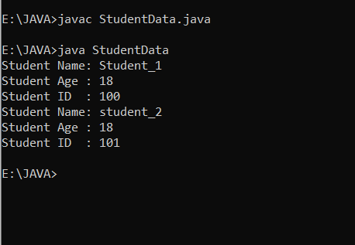

**RESULT:**

Thus, The program has been executed successfully.